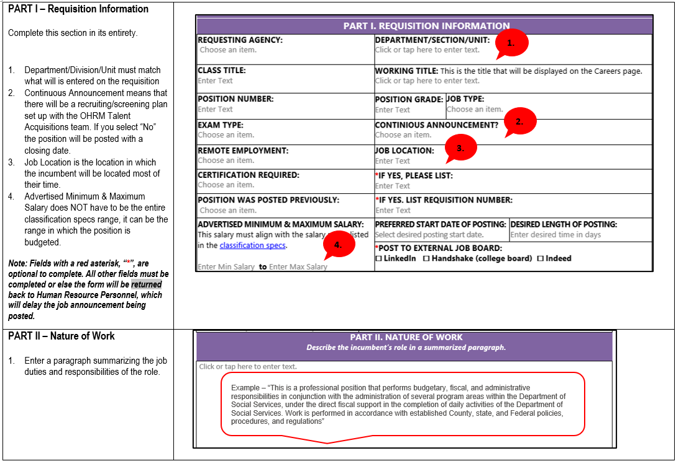

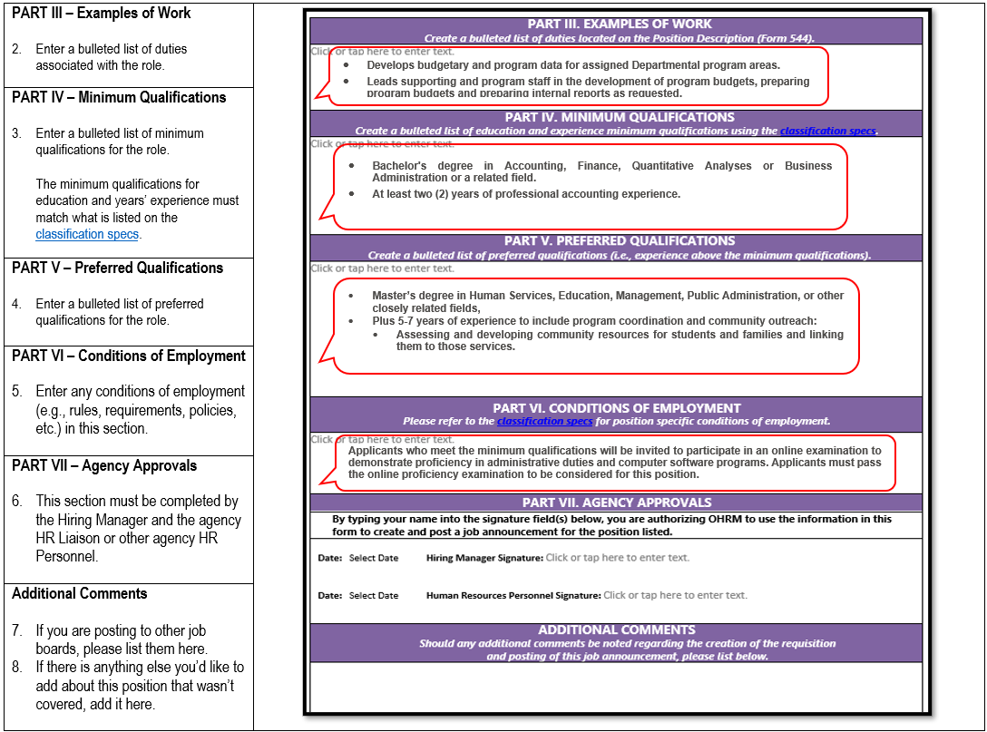

- Hiring Manager: Complete, sign, and send to your agency Human Resources Liaison with any required documentation by your agency to recruit.

- Human Resource Liaison: Review, sign, and attach this form in NEOGOV when creating a requisition.

- Contact OHRMRecruitment@co.pg.md.us with any questions.
Job Announcement Form
PART I. REQUISITION INFORMATION
REQUESTING AGENCY:  Choose an item. | DEPARTMENT/DIVISION/UNIT:  Click or tap here to enter text.
CLASS TITLE:  Enter Text | WORKING TITLE: This is the title that will be displayed on the Careers page.  Click or tap here to enter text.
POSITION NUMBER:  Enter Text | POSITION GRADE:  1 |  | JOB TYPE:  Choose an item.
EXAM TYPE:  Open (default) | CONTINIOUS ANNOUNCEMENT?  No
REMOTE EMPLOYMENT:  On-Site Only | JOB LOCATION:  Enter Text
CERTIFICATION REQUIRED: No | *IF YES, PLEASE LIST:  N/A
POSITION WAS POSTED PREVIOUSLY:  Choose an item. |  | *IF YES. LIST REQUISITION NUMBER:  Enter Text
ADVERTISED MINIMUM & MAXIMUM SALARY: This salary must align with the salary range listed in the classification specs.  Enter Min Salary to Enter Max Salary | PREFERRED START DATE OF POSTING:  9/8/2022 |  |  | DESIRED LENGTH OF POSTING:  Enter desired time in days
*POST TO EXTERNAL JOB BOARD:
☐ LinkedIn ☐ Handshake (college board) ☐ Indeed
PART II. NATURE OF WORK
Describe the incumbent’s role in a summarized paragraph.

Click or tap here to enter text.
PART III. EXAMPLES OF WORK
Create a bulleted list of duties located on the Position Description (Form 544).
Click or tap here to enter text.
PART IV. MINIMUM QUALIFICATIONS
Create a bulleted list of education and experience minimum qualifications using the classification specs.
Click or tap here to enter text.

PART V. PREFERRED QUALIFICATIONS
Create a bulleted list of preferred qualifications (i.e., experience above the minimum qualifications).
Click or tap here to enter text.
PART VI. CONDITIONS OF EMPLOYMENT
Please refer to the classification specs for position specific conditions of employment.
PART VII. AGENCY APPROVALS
By typing your name into the signature field(s) below, you are authorizing OHRM to use the information in this form to create and post a job announcement for the position listed.
Date: 7/12/2022 Hiring Manager Signature: Click or tap here to enter text.

Date: 7/12/2022 Human Resources Personnel Signature: Click or tap here to enter text.

ADDITIONAL COMMENTS
Should any additional comments be noted regarding the creation of the requisition
and posting of this job announcement, please list below.

