Agency Employee Handbook
Agency Name

Table of Contents
AGENCY INFORMATION 2
AGENCY WELCOME 2
HANDBOOK PURPOSE 3
AGENCY MISSION & VISION 4
AGENCY ORGANIZATIONAL CHART 5
AGENCY CONTACT LIST 6
EMPLOYEE INFORMATION 7
EMPLOYEE OFFER LETTER 7
EMPLOYEE POSITION DESCRIPTION 8
EMPLOYEE TECHNOLOGY & LOGIN INFORMATION 9
EMPLOYEE ONBOARDING SCHEDULE 12
COUNTY GOVERNMENT INFORMATION 13
POLICIES AND PROCEDURES 13
COUNTY GOVERNMENT ACRONYMS 17
COUNTY GOVERNMENT CONTACT LISTING 23

AGENCY INFORMATION

AGENCY WELCOME

As a team member of the Office of Ethics and Accountability, you will be counted on and expected to know your job and perform it to the best of your ability. We depend on your efforts to help make the agency a responsive and effective instrument of the Prince George’s County Government. In light of this, please review your job description included in this handbook, which will provide you with a detailed list of the responsibilities and tasks you have been hired to perform. It will also identify your immediate supervisor and outline the day-to-day duties and tasks that are assigned to your position.

Enclosed in this handbook are pertinent information and reference materials that are applicable to your position. You should become familiar with this information, as they will assist you in performing your job. Feel comfortable to ask your immediate supervisor and fellow employees questions to clarify anything that is not clear to you.

As you become familiar with your new assignment, you will have an opportunity to interact with all of the employees of the agency. You will be provided with information on the interdependence of your jobs and the types of activities their offices perform. You are encouraged to learn all that you can about your job and the agency to assist other agency employees in any way you can.

HANDBOOK PURPOSE

The Agency New Employee Handbook is designed to familiarize you with the agency’s functions, address your concerns about your job and provide information and resource materials, which you will need to perform your duties and responsibilities in an efficient and professional manner.

This handbook will provide you with:
- The agency’s vision and mission
- Knowledge of the organization, its policies and procedures
- Information concerning the organization structure, and
- The agency’s employee expectations and standards of performance and conduct

Disclaimer: County employees are responsible for knowing and understanding the policies, which are outlined in this Handbook, the Personnel Law, Executive Orders, rules, regulations and procedures.

AGENCY MISSION & VISION

Agency Mission
Include agency mission here

Agency Vision
Include agency mission here

AGENCY ORGANIZATIONAL CHART

Insert agency organizational chart in this section.

AGENCY CONTACT LIST

Insert agency contact list in this section.

EMPLOYEE INFORMATION

EMPLOYEE OFFER LETTER

INSERT NEW EMPLOYEE OFFER LETTER IN THIS SECTION

- The offer letter should be prepared and signed by the Director welcoming the new hire to the Agency
- The offer letter must include the virtual orientation date and a follow-up one-on-one meeting with the new hire and the Hiring Manager on the second day
- Once the acknowledgement letter is received by the new hire, the HR Liaison will process the new hire information in SAP

EMPLOYEE POSITION DESCRIPTION

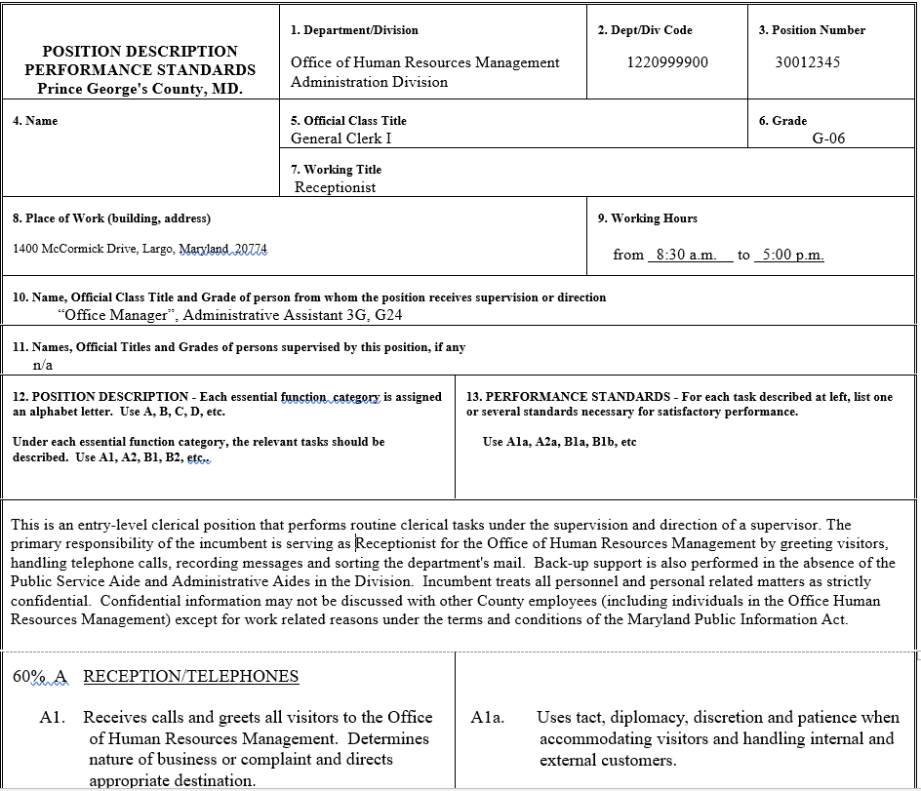
Insert copy of employee’s position description in this section.

EMPLOYEE TECHNOLOGY & LOGIN INFORMATION

Login Information
Your key login and contact information for your Prince George’s County Government account is included below.
Username | Click or tap here to enter text.
Temporary Password | Click or tap here to enter text.
Email Address | Click or tap here to enter text.
Phone Number | Click or tap here to enter text.
Temporary Voicemail Passcode | Click or tap here to enter text.

Office of Information Technology (OIT) Service Desk
- The OIT Service Desk provides technological support for issues including hardware, software, networking, accounts and printing
- The OIT Service Desk can be reached 24 hours a day by calling 301-883-5322

Computer Account
- Each employee in Prince George’s County Government is given a username and a password to log into the network
- This username and password also grant access to Active Directory, Microsoft Office 365 Online, Teams, and email. Certain separate applications (i.e., Kronos and Success Factors) will use single-on while connected to the County network
- When you log onto any computer on the network, you are automatically connected to your specific network resources, along with the resources of the local machine

Password
Your password must meet County requirements:
- Minimum of 8 characters (letters and numbers)
- Case change (upper- and lowercase)
- No part of your name may be used in the password
- Symbols are permitted

Changing your Password
- Your password expires every 90 days
- You must reset your password before it expires in order to keep access to your account
- You will receive a notification when you login to update your password when the expiration of your password is approaching.

Resetting an Expired Password
- To reset an expired password, you must call the County Helpdesk at 301-883-5322

Share Drive
- The Agency Share Drive is personal network-based storage for work-related files and folders
- This storage location is available to you anywhere you login on the County’s network
- The contents of your Share Drive may only accessible by you or by Agency staff depending on the settings
- All data stored on the Share Drive is backed up
- If you need additional access to the Share Drive, please contact the Agency IT Coordinator

Microsoft OneDrive
- All County employees are given one terabyte of OneDrive storage
- Access OneDrive online at https://login.microsoftonline.com/ and enter your County e-mail address
- Enter your County credentials on the Prince George’s County login page

Remote Access
- You can access your County profile (including the H: and I: drive) off-network via the Virtual Private Network (VPN)
- All County computers have Cisco AnyConnect Secure Mobility Client installed
- Once you have connected to Wi-Fi, launch Cisco AnyConnect and enter your login information to sign onto the VPN

IT Ticket System (EasyVista)
- EasyVista is a web-based portal used for tracking all technology incidents and service requests for the Office of Information Technology (OIT)
- Employees with access can submit tickets directly through the platform (Note: not all employees have access to EasyVista)
- If you don’t have access to enter ticket or request, call 301-883-5322, email OITServiceDesk@co.pg.md.us, or contact your Agency IT Coordinator
- Access EasyVista online at https://princegeorgesmd.easyvista.com/

Office 365
- All County employees are given one terabyte of OneDrive storage and a free download of Office
- Access your Office 365 account online at https://login.microsoftonline.com/
- Enter your official County e-mail address and click sign-in. Enter your County credentials on the Prince George’s County login page

Office of Information Technology (OIT) Services Policies:
- OIT has several policies with which you should familiarize yourself; those policies can be found online at http://itranet/sites/oit/policy/Pages/default.aspx
- OIT services policies include:
  - Internet
  - Personal internet is permitted for checking personal email
  - Social media access should be limited
  - All internet and computer usage is monitored
  - County website: http://www.princegeorgescountymd.gov/
  - County intranet: http://intranet/ (this link works only when connected to the County’s network)

Kronos
- Kronos is the timekeeping software used by the County government
- All County employees have a Kronos account that can be used to submit hours worked for approval by your supervisor
- Access the Kronos system online at https://princegeorgescountymd.kronos.net/ using your County email and password

Employee Self Service (ESS)
- The ESS system is used by County employees to access their benefits and personnel information
- The system can also be used access your paystubs as well as change your benefits and payroll information
- Access the ESS system online at https://portal.sap.mypgc.us/irj/portal using your County email and password

The complete and most up to date list of helpful links can be found on the Office of Information Technology (OIT) website at https://www.princegeorgescountymd.gov/3408/Working-Remotely.

EMPLOYEE ONBOARDING SCHEDULE

Time | Task/Meeting | Point of Contact | Topic
Monday | December 5, 2022
9:00 a.m. – 12:00 p.m. | OHRM Virtual Orientation | Agency HRL | - Onboarding information
12:00 – 1:00 p.m. | Lunch | N/A
1:30 – 3:00 p.m. | HRL Welcome Meeting | Agency HRL | - Agency introduction
Tuesday | December
10:00 a.m. – 12:00 p.m. | Supervisor Meeting | Lisa Devlin | - Role overview
2:00 – 3:00 p.m. | Meet and Greet | John Starte | - Role
Wednesday |
10:00 – 11:00 a.m. | Agency Welcome Event | Agency HRL | - Team welcome
12:00 – 1:00 p.m. | Agency Mentor Welcome Meeting | Jane Joy | - Intro meeting
Thursday | DATE
10:00 – 11:00 a.m. | Meet and Greet | John Smith | - Intro meeting
11:00 am – 12:00 p.m. | Kronos Training & Onboarding Questions | Agency HRL | - Kronos review  - Questions
3:00 – 4:00 p.m. | Supervisor Check-in Meeting | Lisa Devlin | - Check-in  - Questions
Friday | DATE
9:00 am – 5:00 p.m. | Office Work | N/A

COUNTY GOVERNMENT INFORMATION

POLICIES AND PROCEDURES

INTERACTION BETWEEN AGENCY EMPLOYEES & CONFIDENTIALITY
Employees are encouraged to be cordial and inquisitive regarding intra- and interoffice job assignments. Individual assignments are an employee’s primary responsibility; however, we all perform better when we work as a team. When time permits, sharing details of division operations with other employees is advantageous to our entire operation. Employees should exhibit sensitivity and concern for fellow workers and should strive to help each other achieve maximum efficiency.

Personal Space
Most employees are in offices; however, conversations—even normal levels—can easily be overheard. Since sound easily travels and discussions can sometimes be overheard, one should make every effort not to eavesdrop. If something is heard, it should be held as confidential.

Disseminating Information
Great care should be taken to ensure that confidential information is not improperly disseminated and that correct information is given. Do not offer gratuitous comments to the public, customers, or stakeholders in your work regarding your opinion of a matter unless you know of what you speak and are authorized to do so. When you receive a request for information, which you are authorized to give, be sure to look up the correct answer the first time.

Confidentiality within Divisions
Teamwork between Divisions is encouraged, but certain forms of information are confidential with its respective Division. Information should only be shared on a need-to-know basis.

Customer Service
Every County employee’s job exists to satisfy the needs and reasonable expectations of our external and internal customers. The agency prides itself on providing high quality services. It is expected that each employee will:
- Use their knowledge, skills and abilities to provide the best service to customers
- Maintain a commitment to excellence in the performance of assigned duties and responsibilities
- Take personal responsibility for ensuring that agency goals and objectives are achieved, and
- Maintain a positive image when communicating with the public, other departments and agencies

Professional Attire
Employees shall dress in a manner customarily expected in the profession. Upon approval of an employee’s supervisor, casual dress will be acceptable when working conditions dictate. Employees are expected to avoid extreme styles of dress or grooming that are unprofessional or disruptive to the workplace.

Casual Friday Attire
Agency Appointing Authorities may allow business casual dress on Fridays. For guidance related to wearing casual attire to work please contact your supervisor or Agency Human Resources Liaison.

Request for Leave
Annual leave must be approved by the employee’s supervisor in advance of use and must be submitted in Kronos in a timely fashion. Generally, the employee should submit annual leave requests for less than five days to their supervisors as soon as the employee is aware of the time of expected use. Annual leave requests of five or more days should be requested at least 14 calendar days in advance of the anticipated leave period.

Supervisors are required to make a timely response to annual leave requests. However, if a supervisor does not respond to an employee’s request within three (3) business days after the leave request is submitted the day before the requested leave, whichever is earlier, the employee may go directly to the supervisor; or, go to the next highest supervisor for approval. When an employee’s annual leave is denied, the supervisor and employee will establish a mutually agreeable alternative leave period.

Attendance and Tardiness
As an employee, you will be held responsible for reporting to your designated worksite as expected and to be on time. Being late or accumulating unexcused absences is unacceptable and may result in progressive disciplinary actions up to termination. If you expect to be late for work, it is your responsibility to contact your supervisor. Your supervisor will determine if you will be excused.

Discipline Policy
As an employee, you are expected to adhere to County policies. It is your responsibility to:
- Be to work on time
- Maintain a satisfactory attendance record
- Perform work assignments
- Work cooperatively with co-workers, and
- Remain alert and active in performing your assigned duties

As outlined in County Code, Subtitle 16 (online at https://library.municode.com/md/prince_george's_county/codes/code_of_ordinances) and Administrative Procedure 224 (available on the County Intranet online at http://intranet/) a disciplinary action or immediate termination will occur if you are involved in, but not limited to, any of the following:
- Drinking or possessing alcohol while on the job
- Using or possessing drugs, drug paraphernalia, or other controlled substances or under the influence of a drug or other controlled substance
- Fighting, assaulting, harassing or otherwise threatening a co-worker or supervisor
- Insubordination, which includes, but not limited to, refusing to work, using abusive language toward other employees while at work
- Leaving your worksite without the permission of your supervisor
- Stealing, or
- Unsatisfactory work performance

Employee Identification Cards
All employees must wear their County-issued employee photo identification cards in all County-operated facilities and when conducting County business. All employees are responsible for maintaining a safe and secure County workplace by wearing the County employee photo identification card and adhering to the regulations of Administrative Procedure 211 available on the County Intranet online at http://intranet/.

Training and Professional Development
The Office of Human Resources Management (OHRM) Center for Learning and Development (CLD) offers several training and development opportunities for County employees. In order to have an effective training and career development program, the needs of our employees must be met. Additional information about training opportunities can be found on the CLD website at
https://www.princegeorgescountymd.gov/3187/Center-for-Learning-and-Development.

Employee Incentive Awards
The agency values its employees and offers recognition incentives. Employee Incentive Awards Program (Administrative Procedure 216, available on the County Intranet online at http://intranet/) provides agencies the opportunity to adopt a recognition program. The agency recognizes employees for exemplary performance in conjunction with the employee’s performance appraisal. Based on the employee’s performance appraisal they can receive the following incentive awards:
- One (1) day of annual leave for an overall rating of “Exceeds Satisfactory” for the past performance appraisal
- Two (2) days of annual leave for an overall rating of “Outstanding” for the past performance appraisal, or
- Three (3) days of annual leave for an overall rating of “Outstanding” for the past two or more consecutive performance appraisals.

Workplace Harassment Avoidance
The Prince George’s County Government has a zero-tolerance policy against harassment and discrimination of employees or constituency for any reason prohibited by law, including sexual harassment. All County employees are required to participate in the mandatory Workplace Harassment Avoidance Training.

Parking
Free parking for all employees is available. There are certain limited areas in which a parking permit is required; these reserved parking spaces are marked.

Telework Policy
Employees can use telework on a situational and routine basis if approved by the agency appointing authority. A telework application must be submitted, approved, and on-file with the agency telework coordinator before any employee uses telework. Employees who wish to use telework are also required to complete an online telework training. Details on how to complete the telework training can be found online on the OHRM Center for Learning and Development website online at
https://www.princegeorgescountymd.gov/3491/Telework-Training.
Policies, guidance, and materials related to telework are available on the OHRM website online at http://ohrm.mypgc.us/.

Administrative Procedures
You can view all Procedures on the County Intranet online at http://intranet/sites/ohrm/Policy%20and%20Procedures/Documents%20Performance%20Mgmt/Forms/AllItems.aspx. Please note that you must be connected to the County network/server either in a County government building or through VPN remote connection to access the Intranet.

Prince George’s County Code
You can view the Prince George’s County Government Code of Ordinances online at https://library.municode.com/md/prince_george's_county/codes/code_of_ordinances.

COUNTY GOVERNMENT ACRONYMS

ADA — Americans with Disabilities Act
ASD — Administrative Services Division
BMP — Best Management Practice
BPRD — Building Plan Review Division
CBB — County Based Businesses
CBCA — Chesapeake Bay Critical Area
CHIP — County Housing and Inspection Program
CLOMR — Conditional Letter of Map Amendment
CO — Correction Order
COMAR 10.15.03 — Code of Maryland Regulations — Food
COMAR 10.17.01 — Code of Maryland Regulations — Swimming Pools/Spas
COMAR 10.26. 04.04 — Code of Maryland Regulations — Wells
COMAR 10.26.04.02 — Code of Maryland Regulations — Septic
COUNTY — Prince George’s County
CPv — Channel Protection Volume
CRSI — Concrete Reinforcing steel Institute
CSR — Customer Service Request
DHCD — Department of Housing and Community Development
DOE — Department of the Environment
DPIE — Department of Permitting, Inspections and Enforcement
DPW&T — Department of Public Works and Transportation
ECI — Engineers Certification of Inspection
ED — Enforcement Division
EEO — Equal Employment Opportunity
EER — Electrical Engineering Review
EIN — Employee Identification Number
EIR — Electrical Inspection Review
EOC — Emergency Operations Center
EOR—Engineer of Record
EPA — Environmental Protection Agency
ERP — Enterprise Resource Planning
ESD — Environmental Site Design
FEMA — Federal Emergency Management Agency
FLSA — Fair Labor Standards Act
FM — Factory Mutual
FPER — Fire Protection Engineering Review
FPIR — Fire Protection Inspection Review
FSF — Food Service Facility
FSM — Food Service Manager
GIS — Geographic Information System
IBC — International Building Code
ICC — International Code Council
ID — Inspections Division
IEBC — International Existing Building Code
IECC — International Energy Conservation Code
IFC — International Fire Code
IFGC — International Fuel Gas Code
IMC — International Mechanical Code
IPC — International Plumbing Code
IRC — International Residential Code
ISO — International Organization for Standardization
ISPSC — International Swimming Pool and Spa Code
IVR — Integrated Voice Response
LAN — Local Area Network
LIS — Legislative Information System
LOMA — Letter of Map Amendment
LOMC — Letter of Map Correction
LOMR — Letter of Map Revision
M/F — Multifamily
MBE — Minority Based Enterprise
MDE — Maryland Department of the Environment
MEMA — Maryland Emergency Management Agency
MEP — Maximum Extent Practicable
MER — Mechanical Engineering Review
MIR — Mechanical Inspection Review
M–NCPPC — Maryland–National Capital Park and Planning Commission
MPIA — Maryland Public Information Act
MSHA — Maryland State Highway Administration
NAAMM — National Association of Architectural Metal Manufacturers
NCMA — National Concrete Masonry Association
NCSEA — National Council of Structural Engineer Associations
NDS — National Design Specifications
NEC — National Electric Code — NFPA 70
NEOGOV — The County’s Recruitment and Application System
NFPA — National Fire Protection Association
NIMS — National Incident Management System
NOAA — National Oceanic and Atmospheric Administration
NPDES — National Pollutant Discharge Elimination System
NRCS — Natural Resources Conservation Service
NRI — Natural Resource Inventory
OCS — Office of Central Services
OEA — Office of Ethics and Accountability
OIT — Office of Information Technology
OMB — Office of Management and Budget
OOL — Office of Law
OSHA — Occupational Safety and Health Administration
OU — Organizational Unit
PCI — Precast Prestressed Concrete Institute
PGSCD — Prince Georges Soil Conservation District
PIN — Position Identification Number
PIO — Public Information Officer
PLD — Permitting and Licensing Division
PLS — Permitting and Licensing System
PMO — Project Management Office
PM — Property Maintenance
PMT — Project Management Team
PO — Purchase Order
PRF — Position Requisition Form
PTI — Post-Tensioning Institute
QA/QC — Quality Assurance/Quality Control Section
QA — Quality Assurance
QAS — Quality Assurance Section
QC — Quality Control
Qf — Extreme Flood Protection
Q-Nomy — Queue Management System
Qp — Overbank Flood Protection
S/F — Single Family
SCON — Street Construction Permit
SCSEP — Senior Community Service Employment Program
SDCP — Site Development Concept Plan
SDFG — Site Development Fine Grading Permit
SDI — Steel Deck Institute
SDP — Site Development Plan (Storm Drain Plan or Stormwater Management Plan)
SDRG — Site Development Rough Grading Permit
SER — Structural Engineer of Record
SFPE — Society of Fire Protection Engineers
SIR — Structural Inspector of Record
SJI — Steel Joist Institute
SLA — Service Level Agreement
SPF — Spruce Pine Fir
SRPRD — Site/Road Plan Review Division
Subtitle 27 — Prince George’s County Zoning Code
Subtitle 32 — Prince George’s County Grading Code
Subtitle 4 — Prince George’s County Building Code
Subtitle 9 — Prince George’s County Electrical Code
Subtitle 11 — Prince George's County Fire Safety Code
SWM — Stormwater Management
SYEP — Summer Youth Employment Program
TCP2 — Tree Conservation Plan Type 2
TC — Time of Concentration
TMDL — Total Maximum Daily Load
TMS — The Masonry Society
TNI — Transforming Neighborhoods Initiative
TPIP — Third Party Inspection Program
UL — Underwriters Laboratories
VN — Violation Notice
VOIP — Voice Over I. P.
VPN — Virtual Private Network
WAN — Wide Area Network
Wi-Fi — Wireless Fidelity (not really an acronym)
WIP — Watershed Implementation Plan
WQv — Water Quality Volume
WSSC — Washington Suburban Sanitary Commission
YTD — Year to Date
ZVN — Zoning Violation Notice

COUNTY GOVERNMENT CONTACT LISTING

The County Executive’s Office provides a regularly updated listing of department, agency, and division head listings through the County Intranet site. The most recent version of the contact list can be found online on the County Executive Intranet site at http://intranet/sites/cex/Pages/default.aspx. Please note that you must be connected to the County network/server either in a County government building or through VPN remote connection to access the Intranet.

